COUNTRY PROFILE
PHILIPPINES
Geography:
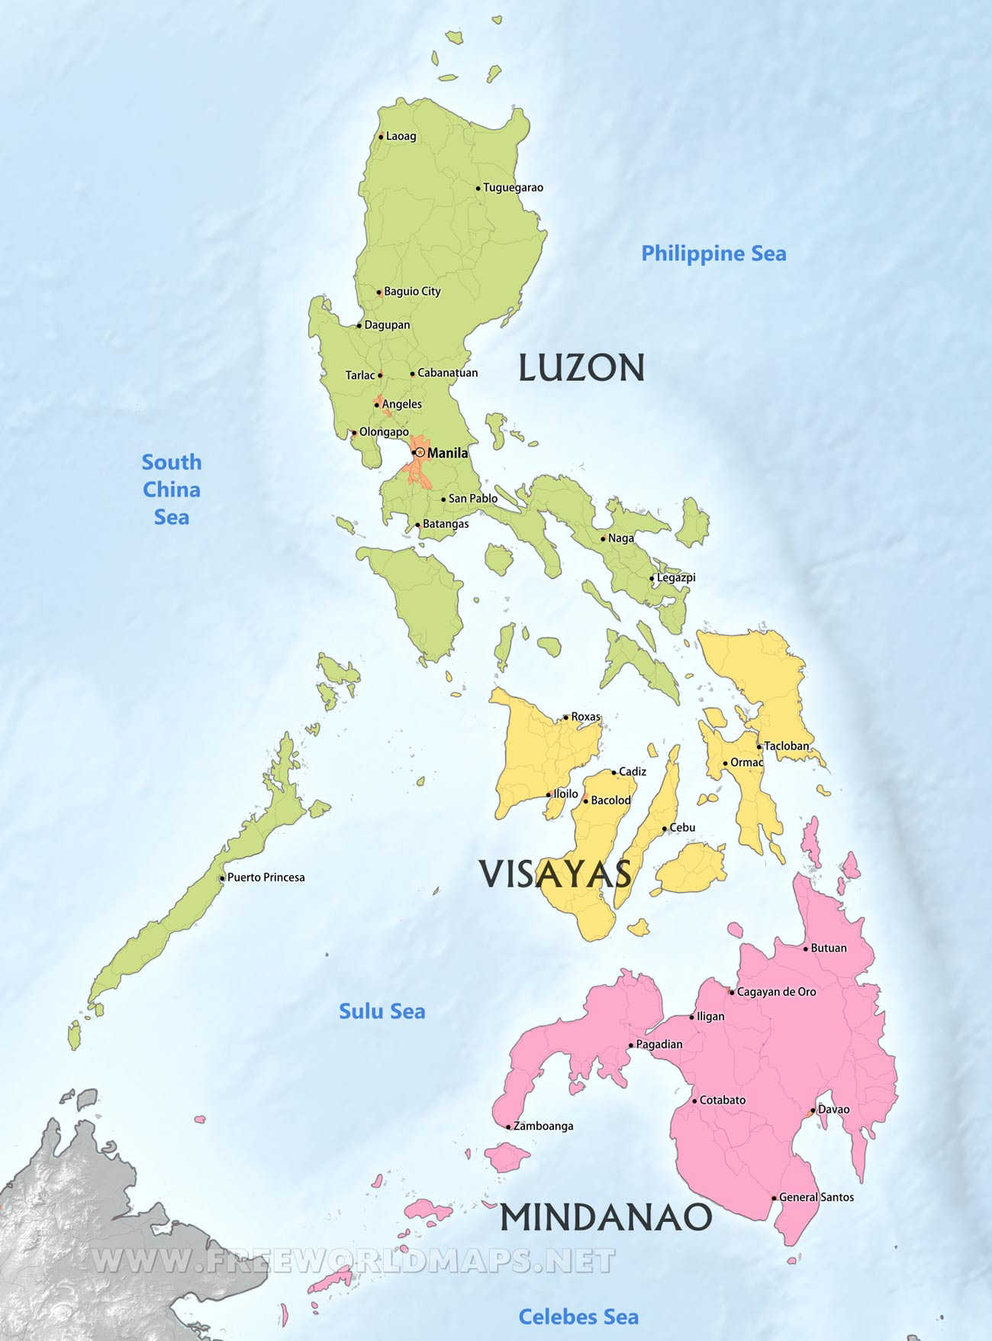
- LOCATION: The Philippines is located in Southeast Asia. Taiwan is in the north of the Philippines, Malaysia and Indonesia on the south, Palau on the east, and Vietnam on the west.

- CHARACTERISTICS: The Philippines has 7,641 islands. The largest islands are Luzon, Visayas, and Mindanao.

- CAPITAL CITY: The capital city of the Philippines is Manila. This city is on the island of Luzon.

- HIGHEST MOUNTAIN: Mount Apo, with a height of 2,954 meters, is the highest mountain in the Philippines.
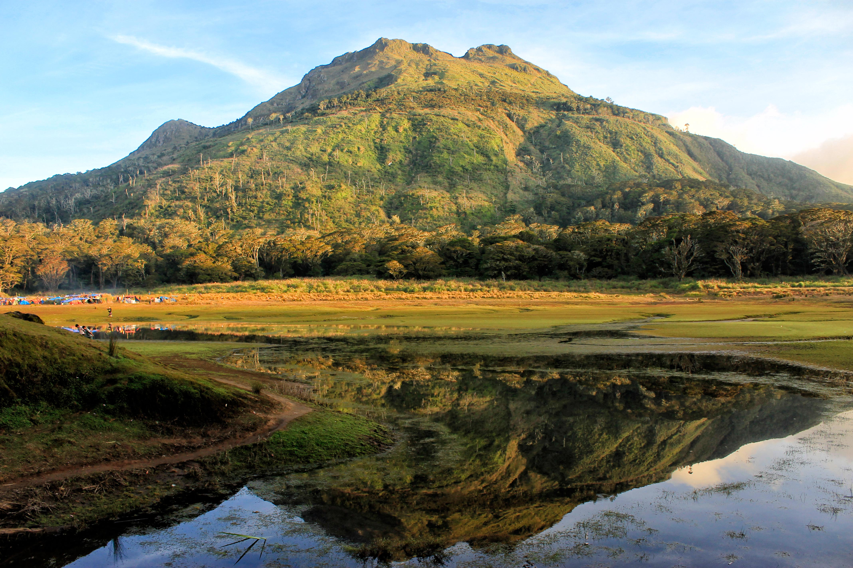
- LONGEST RIVER: The Cagayan River, with a length of 505 kilometers, is the longest in the Philippines.
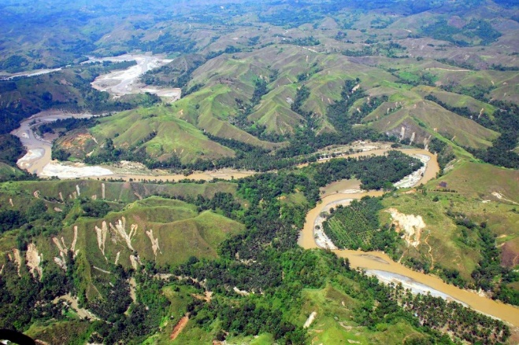
Politics:
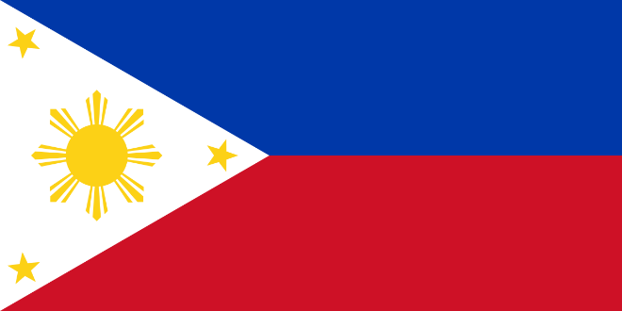
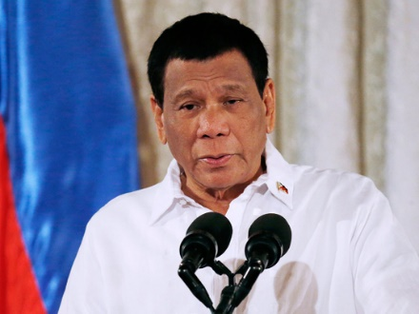
- PRESIDENT: The current president of the Philippines is Rodrigo Duterte.

- FLAG: The Flag of the Philippines has four colors. These colors are Blue, Red, White, and Yellow.

Culture:
- LANGUAGE: There are more than 170 languages spoken in the Philippines. The Official Language of the Philippines is Filipino and English.

- SPORT: The national sport or martial arts in the Philippines is called Arnis.
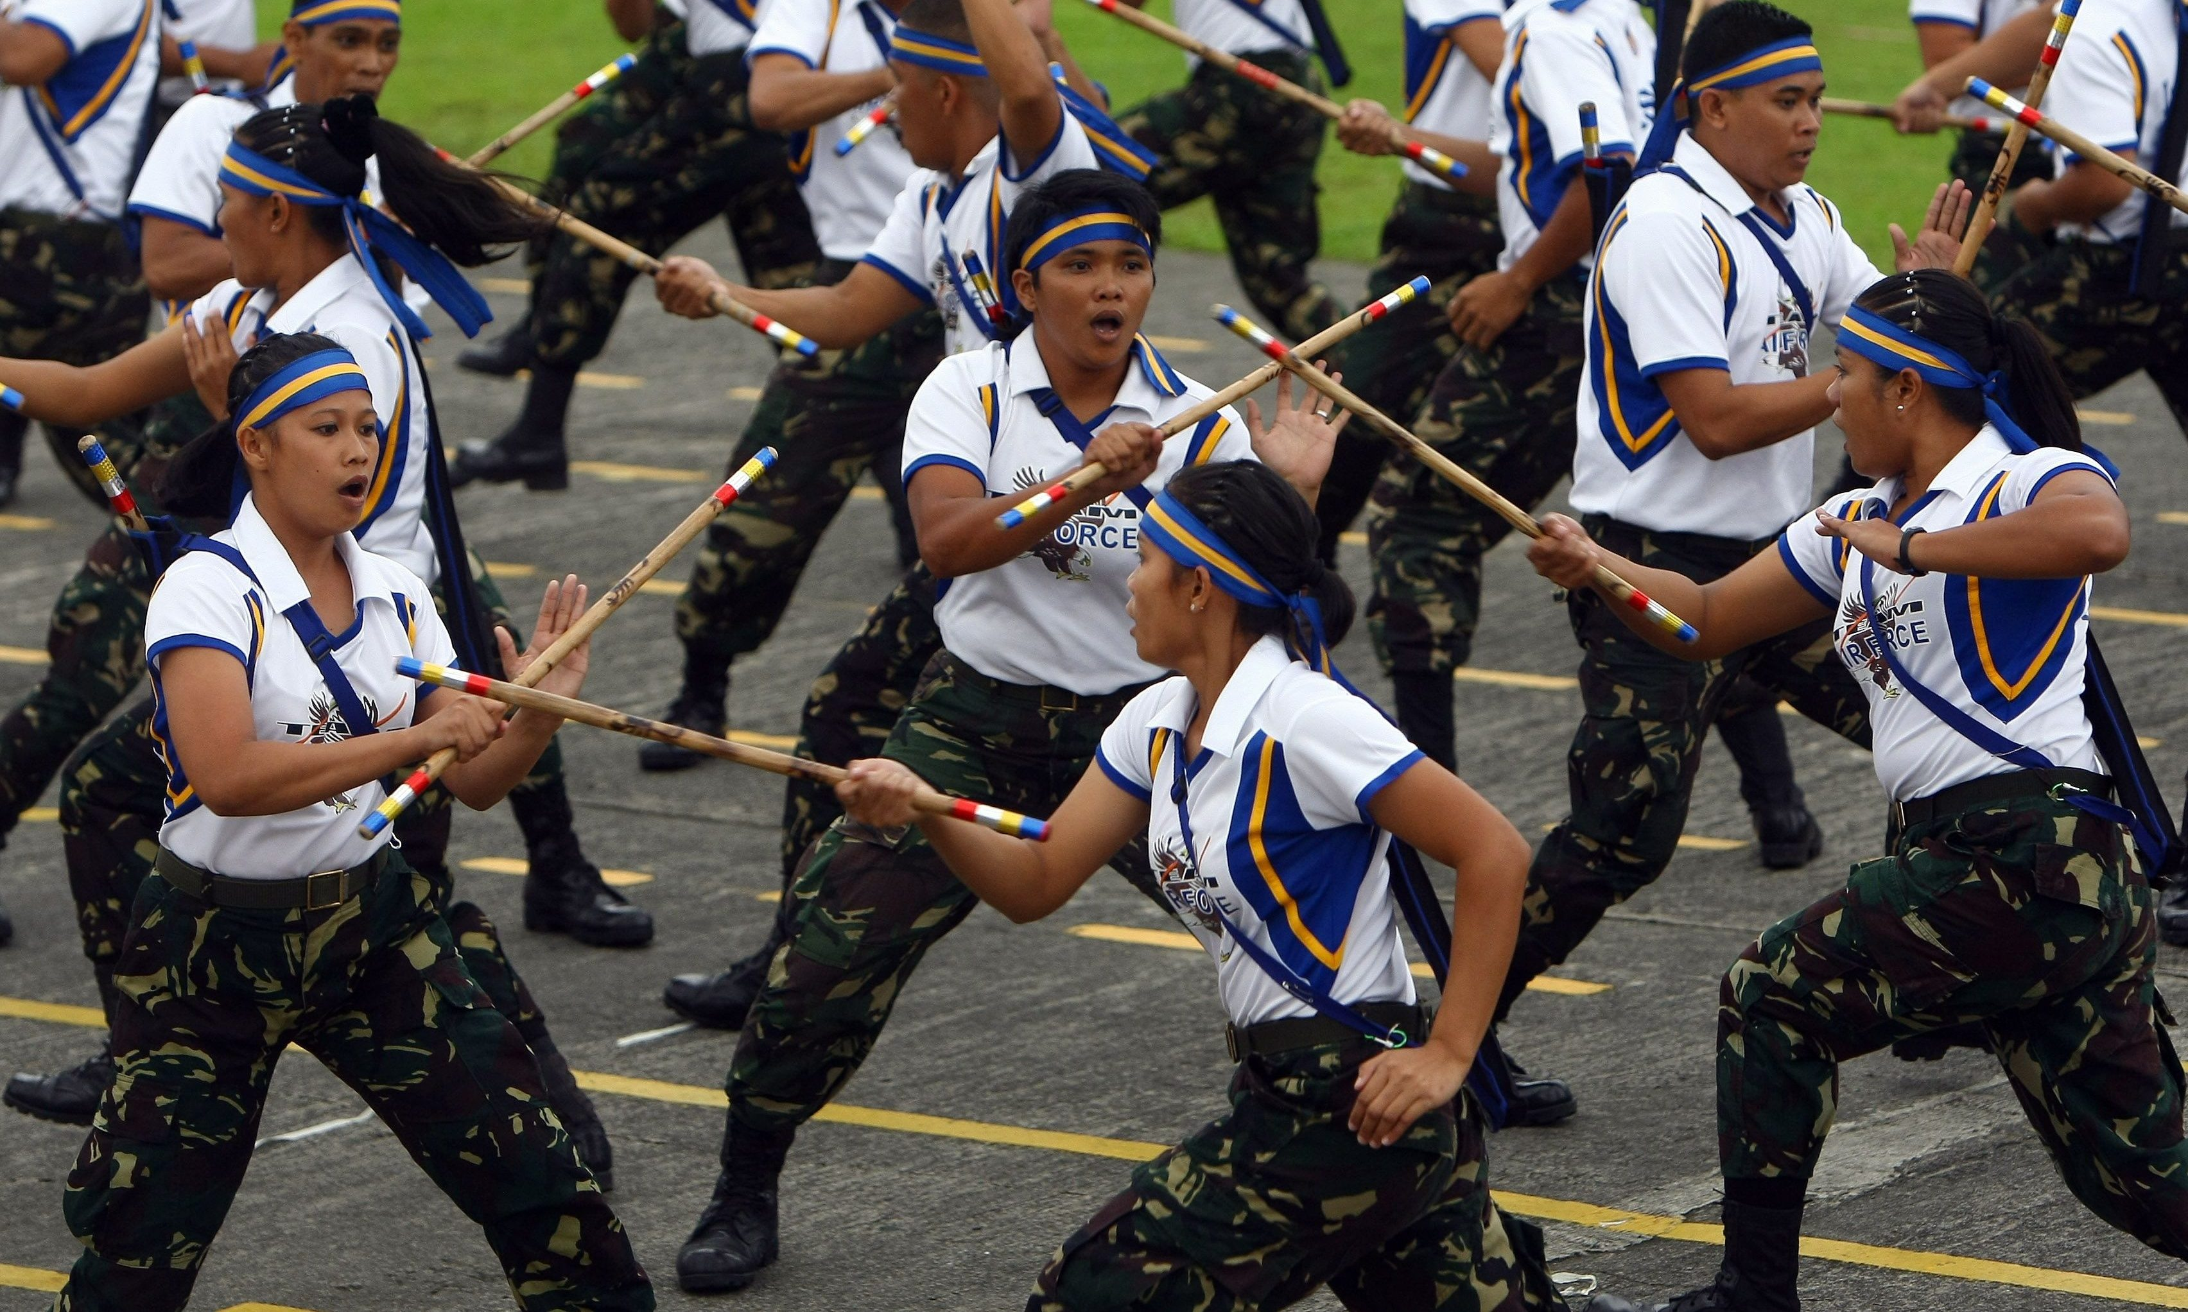
- CELEBRATION: The Philippines has a lot of festivals all year. However, the celebration the Philippines love the most is Christmas. The Christmas season in the Philippines is from September to January.
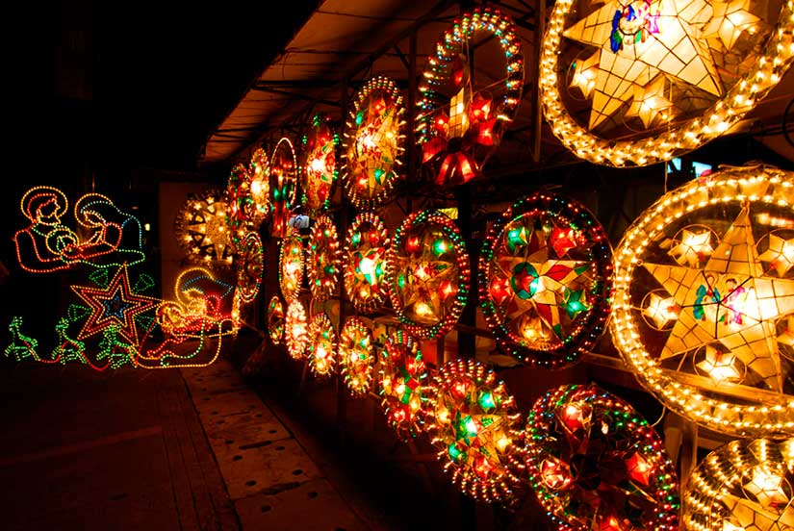
- CULTURAL INFLUENCE: The culture of the Philippines today is heavily influenced by Spain and the United States of America.

